**Independent Design Project Spring 2022**

**Chocolate 3D Printer V2.0**

**Paul Mellor**

**May 3, 2022**

**Part 1: Original Project Overview**

This project started as a Senior Design Project in the fall semester of 2021. The project was to build a chocolate 3D printer (3DCP) that printed chocolate rather than plastic. It had the following customer requirements: [1]

1. The 3DCP must print custom, detailed patterns and shapes out of chocolate.
2. The product must be safe to eat, durable, and taste good.
3. The 3DCP must create the pattern in a reasonable amount of time.
4. The 3DCP must be easy and safe to use.
5. The 3DCP should not require user intervention during the print.
6. The 3DCP must be easy to clean.
7. The 3DCP can be handled by up to two people and fit on the counter.
8. The 3DCP must be presentable and suitable for display.
9. The 3DCP can produce multiple copies during one print.
10. Power consumption is suitable for a standard household wall outlet.
11. The 3DCP must be affordable.

Based on the requirements we were given for Senior Design, a quantified list of design specifications were created as the goals we intended to meet for the project. [1]

1. Through a combination of nozzle diameter, a recommended melting temperature of 31-36 °C, motor precision, and motion tolerance, the printer must be able to produce details as small as 2 mm. The 3DCP nozzle diameter must not exceed 2 mm.
2. All parts of the 3DCP that come in contact with chocolate must be able to be washed and be nontoxic in the 31-36 °C region. For example, any chocolate in contact with vinyl tubing must not exceed 79.4 °C.
3. The volumetric flow rate should be at least 25 cm3/hr.
4. All conductible materials near the heat source will have insulation or a cover and no material will exceed 60 °C to avoid burns.
5. The 3DCP must store chocolate for the entire print: at least 100 cm3 of chocolate.
6. The parts must be able to come apart and fit together in order to clean easily. To remain dishwasher safe, all materials must have a melting point above 180 °F.
7. OSHA standards specify that two people can comfortably carry 102 lbs. This 3DCP will not exceed 51 lbs. The dimensions of the base will not exceed 2ft x 2ft
8. The 3DCP must have a viewing window that is at least 10 cm x 10 cm. All wires, motors and electronics will be hidden.
9. The 3DCP must have a build area that is at least 10 cm x 10 cm.
10. The 3DCP must not use more than 1500 W of power.
11. The 3DCP fabrication must not exceed $1000 in purchased and manufactured parts.

These specifications drove the design choices we made for the original 3DCP.

**Initial Design**

The CAD model for the original design is shown below in Figure 1.

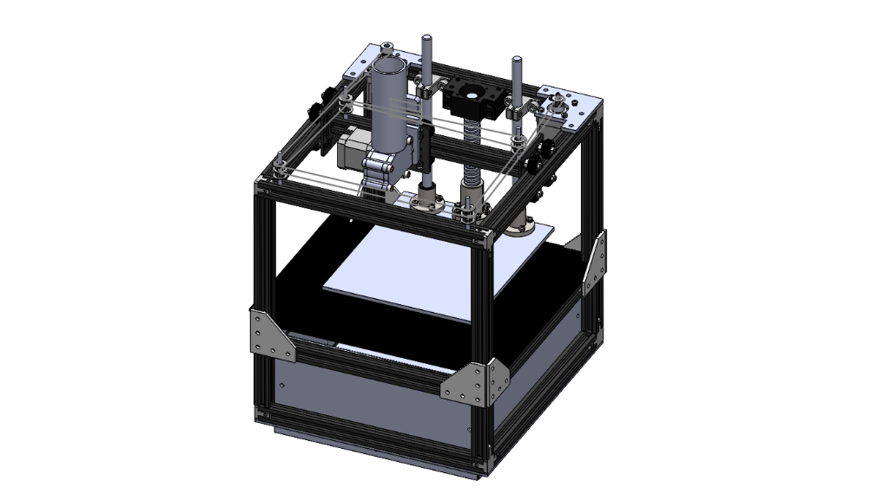

Figure 1: CAD model of the original 3DCP

To get a system that moved in 3 dimensions, the motion system moved the extruder in the x-y plane while the build plate moved in the z direction. This was selected in order to minimize the amount of power needed to quickly move the mass of the extruder body, vat, and chocolate against the force of gravity. Starting with this principle, a CoreXY motion system was identified which met the design specifications. Based on a specific arrangement of timing belts, it allows the extruder to move anywhere in the x-y plane while the motors are fixed in place. A diagram of this belt arrangement is shown in Figure 2.

Figure 2: CoreXY diagram

The build plate was moved in the z direction using a combination of a lead screw and linear guide rails. The gear reduction provided by the lead screw meant that a powerful motor wasn’t necessary to hold the build plate against gravity. The guide rails kept the build plate stable and took the bending loads of the bed.

The extruder design was modelled on a commercially available design called the ChocoL3D extruder [2]. This was a gear-pump based design as opposed to the more common syringe design. The gear pump extruder was chosen initially in order to minimize space taken by a large syringe body and to improve the aesthetics of the design. It also allows better control for stopping and starting the extruder. Several iterations of the extruder were prototyped and tested before the design was finalized and fabricated. The extruder design is shown below in Figure 3.

**Electronics**

The original design used an Arduino Mega as the microcontroller for the printer. It used a “RAMPS 1.4 3D Printer Shield” that allowed it to interface with motors, heaters, and sensors. The motors selected were stepper motors. They were simple to use with Arduino code, easy to position with a high degree of precision, compatible with the RAMPS Shield, and powerful enough to move the CoreXY motion system. 12V Electric heating elements were selected to heat the gear pump and the vat for the extruder. Each also had a corresponding thermistor to provide temperature feedback to the Arduino. A wiring diagram is shown in Figure 3.

Figure 3: Wiring diagram of the Arduino

**Software**

In the original software system 3DCP began with a stereolithography (.STL) file for the desired print object. The .STL file was imported into Cura, where it gets sliced and a G-Code file generated. The G-code file was converted into a .txt file and imported into MATLAB. A MATLAB program parsed through the .txt file to interpret the G-Code and convert it to the necessary coordinates to position the motors. The MATLAB program identified redundant layers from the slicer to optimize storage space on the Arduino. The program outputted three matrices of data points. The first two are the X and Y coordinates of the extruder. The third is a matrix full of ones and zeros indicating if the extruder should be extruding during a given pass between points.

These matrices were copied and pasted into the Arduino code and uploaded to the Arduino board. The Arduino code then iterated through the matrices and performed the necessary calculations for CoreXY to move the extruder carriage via two stepper motors. A third stepper motor lowered the base plate between layers of chocolate. Once the Arduino code was compiled, the board is connected to power to start the print. Figure 4 is a flowchart outlining the sequence of the original software.

Figure 4: Flowchart of the Software System.

**Results at the End of Senior Design**

Figure 5 shows the 3DCP at the conclusion of Senior Design.

Figure 5: 3DCP at the Conclusion of Senior Design

It was able to meet the criteria set for the project as outlined above. To demonstrate the capability of the 3DCP at the end of the semester, a number of chocolate patterns were printed, such as the ND Monogram, the Leprechaun, and Touchdown Jesus shown in Figure 6 below.

Figure 6: Chocolate ND Monogram Demonstration Print

Additionally, the 3DCP was capable of larger 3D prints, like the chocolate vase also pictured above in Figure 6.

**Problems**

While this senior design project was successful, it was a good first iteration with significant room for improvement. There were a number of issues that limited the printer’s capability, and made it difficult to use. The first issue was the workflow required to go from 3D model to completed 3D print. Using MATLAB to process the G-Code was confusing and unintuitive. Reprogramming the Arduino for every new print was also a step that anyone without programming experience would have a hard time completing, and made the 3DCP a rather unadaptable system. This also had an unintended consequence – by making the coordinates for the 3D print part of the code, the size of the print file was limited to the amount of flash memory on the Arduino. In practice, this meant that any of our 3D prints had to contain less than ~800 distinct coordinates, severely limiting the complexity of geometry the 3DCP could print. This effectively limited the 3DCP to printing a “thick 2D print” (printing the same pattern for every layer).

- requirement of computer

- workflow to go from 3D model to actually printing

- limit to 2D shapes

- wait time between layers

Another problem with the 3DCP is that the chocolate took several minutes to solidify. This meant that 1 layer could be printed reasonably quickly, but then the printer would have to wait several minutes between layers before printing the next layer. The result was print times that were sometimes double or triple in length to the time the printer spent actually moving.

- reliability (extruder working inconsistently, broken ball screw)

The last major problem the 3DCP had was reliability problems. First, extruder performance was inconsistent. Sometimes it would produce consistent flow of chocolate, sometimes it would only extrude chocolate in bursts, and sometimes it wouldn’t extrude any chocolate. Part of this had to do with a finicky pre-heating procedure which involved reprogramming the Arduino with separate code just to get everything up to temperature and flowing.

**Part 2: The Second Iteration to Create Printer 2.0**

With the foundation of the 3DCP from Senior Design, new goals were set to create a second iteration of the 3DCP. These new additional goals were:

1. The 3DCP is able to print true 3D files. This includes more difficult structures like overhangs and bridges.
2. The 3DCP can manage the heat of the printed chocolate such that it does not have to stop printing in order for it to cool.
3. The 3DCP is user friendly enough that it can be operated by an average person who isn’t necessarily experienced with 3D printing.

**Software Changes**

For the second iteration of the 3DCP the software was completely overhauled. The Arduino was programmed with an open source piece of code called “Marlin”. Marlin is a customizable piece of firmware specifically written for 3D printers. It is used on many commercial 3D printers. It has a built-in G-code interpreter and can print directly using a G-code file. It handles all of the kinematics of the motor, with built-in configurations for CoreXY motion systems. It handles the heaters using sophisticated PID controllers. It has built-in functionality for adding a user interface. Finally, it designed to use an SD card (or some external storage media) for storing G-code files.

Switching to Marlin has significant advantages over the original code written for the 3DCP. First, it greatly simplified the workflow going from a 3D file to a printed 3D object. Instead of slicing in Cura, parsing in MATLAB, and reprogramming the Arduino, the sliced file straight from Cura only needs to be placed on an SD card and connected to the controller. Someone with little to none programming experience can translate a 3D file into something the 3DCP can print with Marlin. Second, the use of an SD card effectively removes the limitation on the number of coordinates for the 3D print. Even highly detailed 3D models don’t come close to the gigabytes level capacities of an SD card. Finally, if G-code files are left on the SD card, the 3DCP can be operated without any access to a computer whatsoever.

**Cooling System**

For the second iteration of the 3DCP, a cooling system was added to the printer. To decrease the time needed to print, the extruded chocolate needed to solidify as quickly as possible. Two approaches were considered to solve this issue: either cool the chocolate using conduction through the build plate, or cool the chocolate using forced convection from a fan. Conduction was ultimately decided against. While chilling the build plate would likely be very effective at cooling the first few printed layers, the more layers that were built up, the less effective conductive cooling would be. Since convection could provide consistent cooling performance regardless of the number of layers in the print, a study was done to see if forced convection from a fan could effectively cool the chocolate more quickly.

To find the feasibility of using convective cooling to help solidify the chocolate, a cooling calculation was done to simulate how effectively convection could cool a layer of chocolate. A 20mm x 20mm x 1.5mm box was used to represent the shape of a single chocolate layer. Using the lumped capacitance method, the temperature $T$ of the chocolate as a function of time is given by:

$$T\left(t\right)=T_{∞}+\left(T_{0}-T_{∞}\right)e^{-\frac{t}{τ}}$$

where $T_{∞}$ is the ambient temperature, $T_{0}$ is the initial temperature, and $τ$ is the time constant. $τ$ is equal to

$$τ=\frac{c_{p}ρV}{hA}$$

where $c_{p}$ is specific heat (1006 J/kg-K) [4] , $ρ$ is density (1.225 kg/m^3) [4], $V$ is volume, $h$ is the convection coefficient, and $A$ is surface area. $h$ for forced convection from a fan was taken to be a conservative 60 W/m^2-K [4]. A plot comparing the forced convection from a fan to natural convection is shown in figure 7.

Figure 7: Theoretical Convective Cooling for Chocolate

This demonstrated that adding a fan would make a significant difference in cooling the chocolate quickly. Based on Figure 7, cooling the chocolate from the print temperature of 40 ℃ to below to melting point of 32 ℃ only took 25 seconds – significantly less than the 3+ minutes required between layers at the end of senior design. Based on this proof of concept, a cooling fan was added to the extruder, shown in figure 8 below.

Figure 8: Cooling System on the Extruder

**User Interface**

For the second iteration of the 3DCP, a user interface was added. A small display and a control knob were added to the front of the 3DCP. The screen can be used to show useful information about the printer, show menus for controlling and configuring the printer, and initiate 3D prints. The control knob can be used to navigate these menus and select items. In conjunction with Marlin as the firmware, a whole host of useful functionality is now readily available to anyone using the printer. Examples of the home screen and available menus are shown in Figures 9 and 10 below.

Figure 9: Home Screen

Figure 10: Menus on the 3D printer

**Documentation & Resources**

In addition to adding a user interface, a whole host of documentation and resources were created to make the 3DCP accessible and usable by inexperienced persons. First, the SD card on the 3D printer is loaded with multiple premade print files. A user can simply plug the printer in, select one of these files, and the printer automatically starts. No experience with a 3D printer slicer is required.

If a user wants to print their own 3D model, a slicing profile was created for CURA Slicer. Uploading this profile automatically changes the slicer parameters (layer thicknesses, line widths, flow rates, temperatures, retraction settings, supports, etc) to specifically work with the 3DCP. This allows someone without much experience with 3D printing slicers to still print their own custom 3D models.

Finally, the biggest resource created for the 3DCP was a user guide. This guide gives step-by-step instructions for turning on and warming up the printer, generating the G-code files for 3D prints, and starting a 3D print. It also includes a troubleshooting guide to help fix common issues that might occur with the 3DCP. This document is attached in the Appendix.

**Results**

Figure 11 shows the 3DCP at the conclusion of the spring semester.

Figure 11: 2nd Iteration of the 3DCP

Most of the printer remains unchanged from the first iteration, but its capabilities have vastly improved in terms of printer performance and usability. The 3DCP is now able to print true 3D models with complex geometry. An example of what it is now capable of printing is shown in Figure 12.

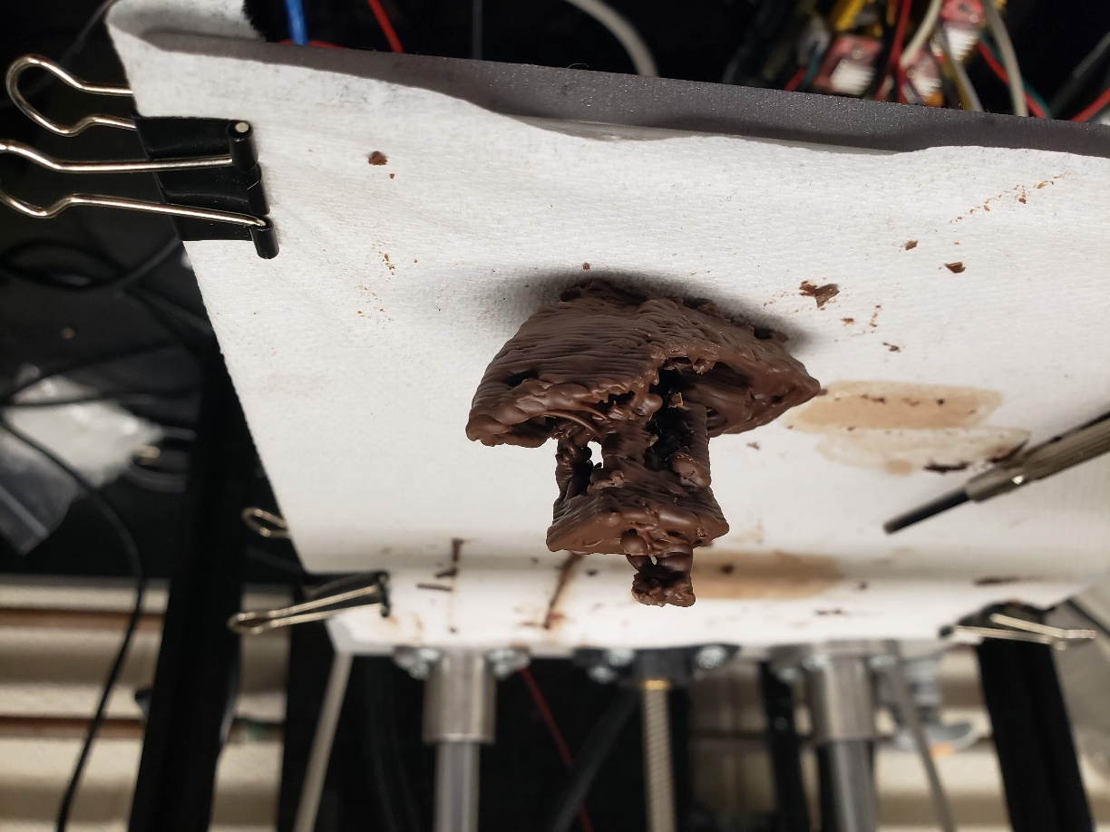

Figure 12: Example of Chocolate 3D Print Compared to the 3D Model

This print has overhangs, bridges, complex details, and was printed in only 30 minutes. The finished print is dimensionally within ±1mm of the original 3D model. Finally, the 3DCP was able to cool the chocolate well enough that it only had to pause between layers for the uppermost layers of the smokestack that only took a few seconds each to print.

To evaluate the user friendliness of the 3DCP, several people unfamiliar with the 3DCP were given the user documentation and resources and shown the 3DCP. They were then asked print the model shown in Figure 12 (The print file was premade and already loaded on the SD Card in the 3DCP). All of them were able to successfully start the print with the use of the provided resources. One person was even able to start the 3D print without consulting the documentation whatsoever, and commented that the menus on the printer were surprisingly intuitive to follow.

**Remaining Areas for Improvement**

This second iteration of the 3DCP represented a huge step forward for the 3DCP, but there are still remaining areas where the 3DCP could improve. First, the 3DCP still only works with one kind of chocolate. More time could be spent testing with different chocolate types and tuning the printer to work with different materials. This would make the printer more flexible/adaptable instead of locking it to exclusively the chocolate it prints with now.

Secondly, the 3DCP does not print with a consistent line width, especially at slow speeds. This is likely due to the gear pump design for the extruder not producing consistent pressure at low speeds. A combination of redesigning the geometry of the gear pump and increasing the print speed could either mitigate this issue or fix it altogether.

Third, the gear pump design does not work well with smaller nozzle sizes. For nozzles smaller than 1mm in diameter, the extruder tends to jam and does not extrude at all. Redesigning the gear pump may fix this problem, but this may also be a limitation of the gear pump concept for the extruder.

Finally, the 3DCP lacks some features that are common “nice to have” features often found on many normal 3D printers. It does not have a bed levelling mechanism, quiet motors, a camera to watch/record the printing process, or internet connectivity. While not strictly necessary to the operation of the 3DCP, these are features that would make the 3DCP a more well rounded product.

**Appendix A: References**

[1] *Senior Design Design Proposal*, Group 5, Notre Dame AME Senior Design Fall 2021

[2] ChocoL3D, L3D Extruder’s Body. <https://chocol3d.com/product/l3d-extruder-kit/>

[3] *Convection Heat Transfer Coefficients,* Philip Kosky, <https://www.sciencedirect.com/topics/engineering/convection-heat-transfer-coefficient>

[4] *Air Specific Heat Capacity,* Engineering Toolbox, <https://www.engineeringtoolbox.com/air-specific-heat-capacity-d_705.html>